Query 1:  
  
Top 3 records after re-rank for query 1:

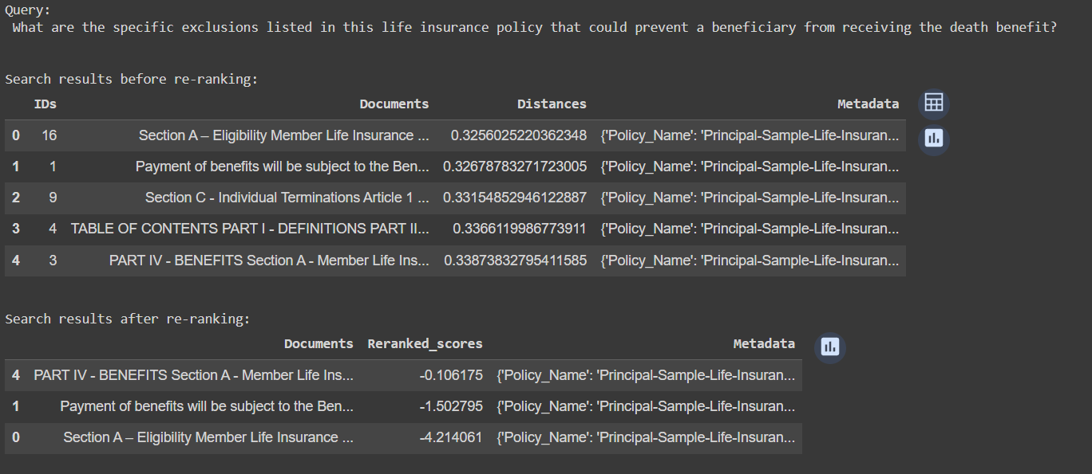

Generative Layer Answer for query 1:

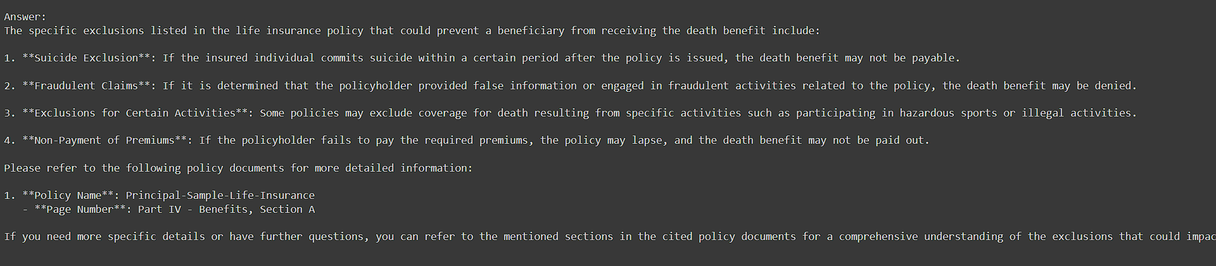

Query 2:

Top 3 records after re-rank for query 2:

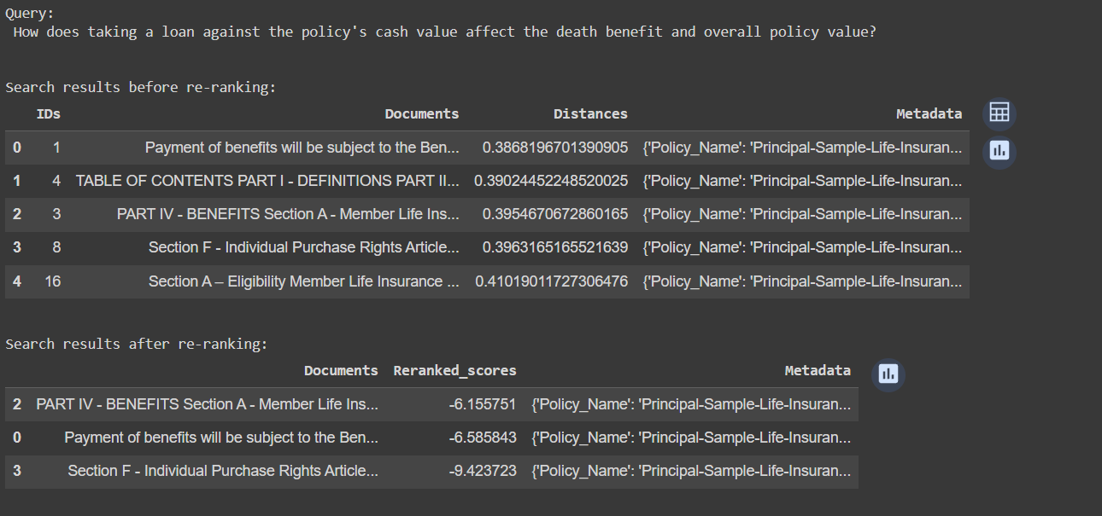

Generative Layer Answer for query 2 :

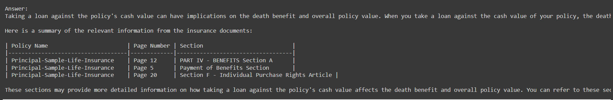

Query 3:

Top 3 records after re-rank for query 3:

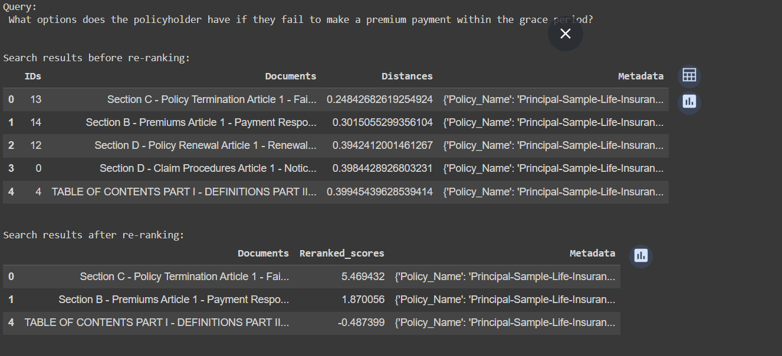

Generative Layer Answer for query 3:

